Conf+

User manual

Matthew boroczky  
Michael Kong  
Loo yee liew  
ruixi HE  
Chee Yeong Lim  
Sandon Joubert  
junyan fan

2015

Table of Contents

Overview 3

Key Areas 3

Header 3

Menu 3

Main Content Area 3

Account Management 4

Registering 4

Logging In 4

Update Profile 5

Upgrade Account 5

Attending Events 7

Searching for Events 7

Buy Tickets 7

Submitting Papers 8

Organising Events 9

Create Event 9

Select Reviewers 9

Assign Papers 9

Review Reviewer Responses 10

Review Reviewer Reviews 10

# Overview

Conf+ is a easy to use, user-orientated system for creating, managing and attending large social events. This user manual will show you how to use some important features of the system, further tips and help can be found on the website.

## Key Areas

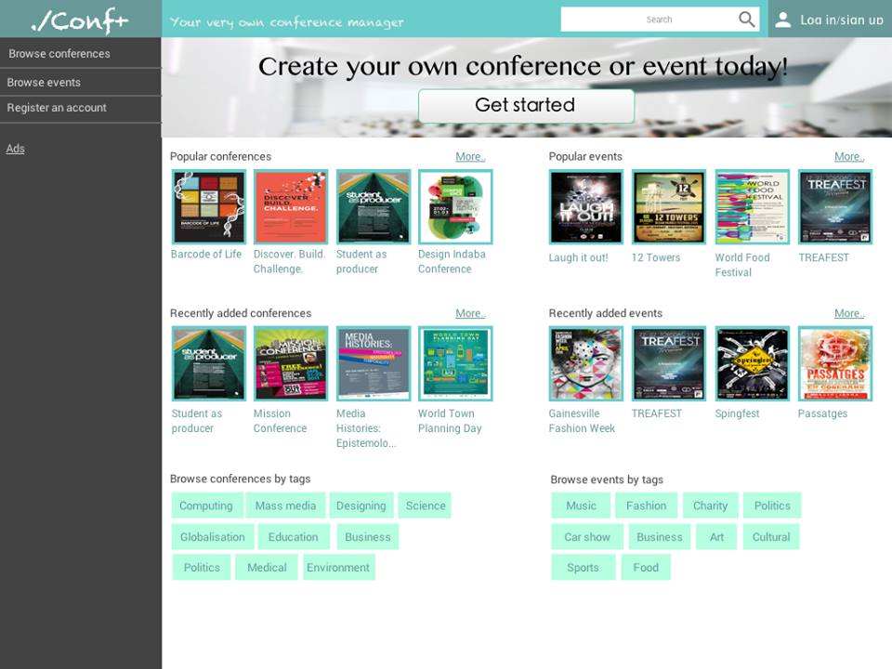

### Header

The header is the green strip at the top of each page. From left to right it contains our name and slogan, a search bar and the account panel.

### Menu

The menu is the dark grey area situated on the left of each page, it contains many different options depending on which page you are on. On smaller devices (ie mobile devices) it will be hidden by default but can be revealed by clicking the hamburger menu ‘☰’ to reveal it.

### Main Content Area

The main content area is everything not a part of the last two mentioned areas. It contains all the information associated with each page you are on.

# Account Management

## Registering

There are two ways you can register your account to become an authenticated user. You must be authenticated to buy tickets to events.

Registering through the register page:

1. At the top right of any page there will be a button called ‘Register’, click this
2. Fill in your name, email and password. It is required that you use a valid email address.
3. Click ‘Register’ at the bottom of the form. An email will be sent to your specified account with a link to validate your account.
4. You may now log in

Registering through purchasing tickets:

1. Purchase tickets (see Attending Events → Buy Tickets pg. XX)
2. After purchasing your tickets you will be sent an email with an automatically generated password. Log in (see Account Management → Logging In pg. XX) using the password to confirm your new account. It is recommended that you change the password immediately.
3. You have successfully registered and logged in

## Logging In

Logging in is a straightforward process but necessary to use some more advanced features of the site.

1. At the top right of any page there will be a button called ‘Log In’, click this. It will navigate you to the Log In page.
2. Enter in your email and password. Click ‘Log In’.
3. If your credentials are correct you will be redirected back to the last page you were on. If not you will be asked to re-enter your credentials correctly.

Update Profile 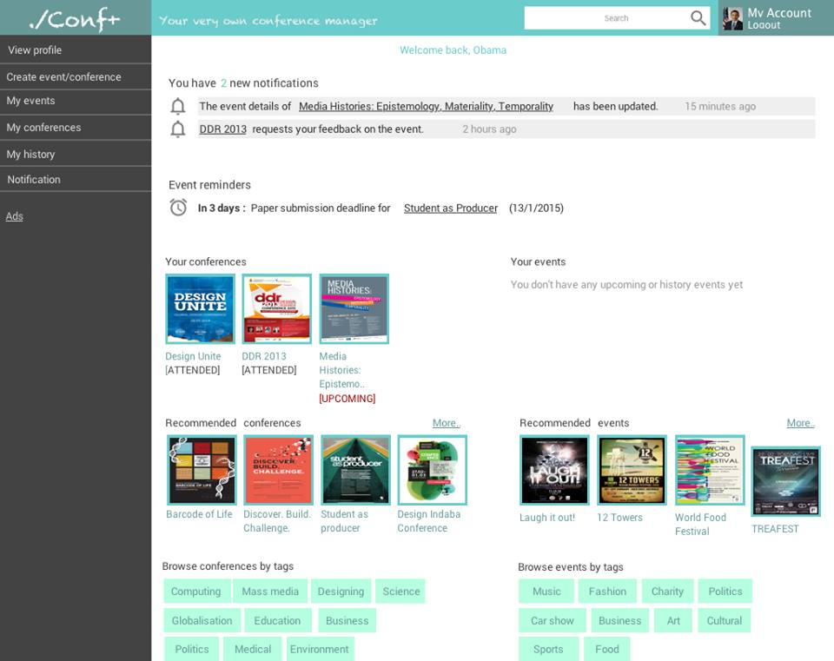

Updating your profile can be done through the My Account page.

1. Log In (see Account Management → Logging In pg. XX)
2. At the top right of the page, where the ‘Log In’ and ‘Register’ buttons were, click the ‘My Account’ button.
3. On the menu select ‘Update Profile’
4. Here you can change your password, email or any saved billing information
5. Click save to save the changes made

## Upgrade Account

Upgrading your account let’s you benefit from everything Conf+ has to offer. It can be done through the My Account page

1. Log In (see Account Management → Logging In pg. XX)
2. At the top right of the page click the ‘My Account’ button
3. On the menu select ‘Upgrade Account’
4. You must enter your billing information either as new information or from saved records
5. Click ‘Upgrade’, your request will be processed and you won’t be billed until your upgrade has been approved. Once approved you will receive a notification in your ‘My Account’ dashboard and have more options opened up to you.

# Attending Events

## Searching for Events

Searching for events is easiest way to find the events you’re looking for.

1. Locate the search bar at the top center of the page.
2. Enter in the name of the event you want to search for (you may also search for events via tags)
3. Press enter or click the search icon
4. A list of the most related searches will be produced in the main content area.

## Buy Tickets

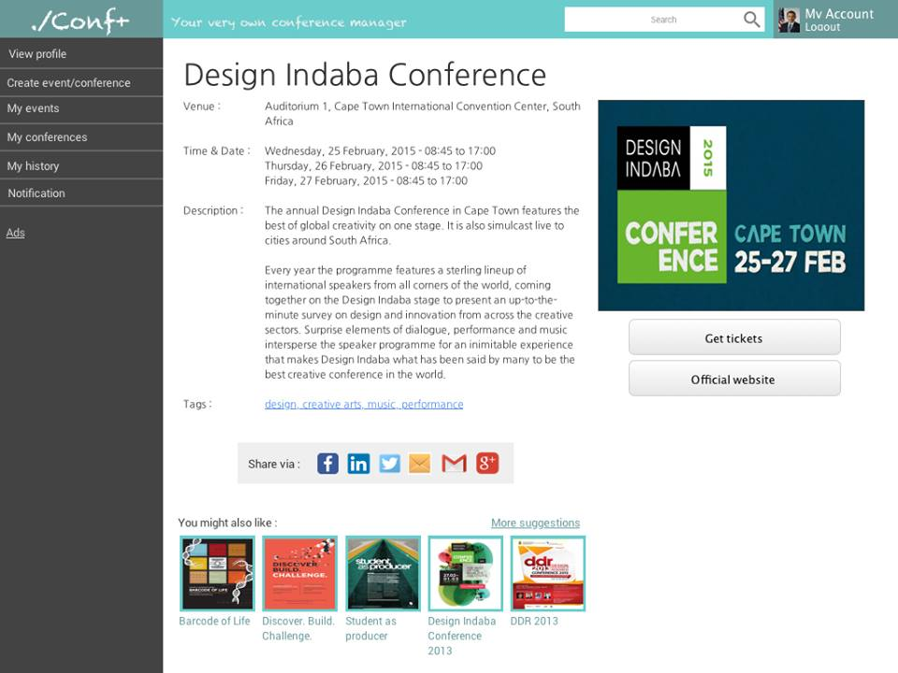

Purchasing tickets can be done from any events main page.

1. Go to the event main page. This can be done either from a link sent to you, searching for an event or clicking any suggested events in the site.
2. In the main content area to the right click the ‘Get Tickets’ button
3. Different conferences will have slightly different flow of events here but will follow something similar to:
   1. Select seat, seat type and ticket type
   2. Repeat for all sessions attending

It should be noted that some events will not have any seating while others may have session paid for externally outside of the system (such as through eventbrite).

1. Continue to check out screen. Enter in your billing information, you may used previously saved information.
2. Enter in the details of any guests you are purchasing tickets for.
3. Click ‘Confirm’

## Submitting Papers

To submit a paper to a conference you must first become an authorised author for that event. To do so you must:

1. Go to the event page
2. On the right hand side of the main content area click ‘Register as Author’
3. Wait to be accepted, in the meantime make sure your Paper is in a format ready to go to upload to the event. Make sure your abstract does not contain any details about any of the authors and is in PDF format

Once you have been accepted you will receive a notification in your account dashboard. Upon going back to the event page you will notice a new option:

1. On the right hand side of the main content area where you clicked ‘Register as Author’ click ‘Submit a Paper’
2. You will be redirected to a file upload screen with some form details. Enter your details and upload your paper. Note: This is a preliminary upload, you have not yet submitted your final version. You have up until the assigned deadline date to make any modifications you wish to your paper. At any point before the deadline you may ‘Submit Final Version’ for your paper to be submitted.
3. Sit back and relax, any notifications to do with your paper will come through your account dashboard.

# Organising Events

Everything in here applies mostly to those who want to organise their own event or conferences. You must have an upgraded account to create events. Most of the more complicated parts are only associated with Conferences and do not apply to Events.

## Create Event

1. Log In
2. In the menu click ‘Create Event/Conference’
3. Select whether it will be a conference or event.

For events:

1. Enter essential information including: date, venue, name, poster, description, tags, etc.
2. Click save or publish. Save will let you modify more parts but does not make the event accessible to anyone but you yet. Publish will allow users to start accessing the Event page.

Many conferences differ this is an example set up:

1. Enter essential information including: date, venue, name, poster, description, tags, etc.
2. Pick deadline dates for paper submission, paper review response and paper review.
3. Don’t be hesitant to use our online help

After creating either an event or a conference at anytime you may go back and add or edit information such as venue maps and deadlines, all users affected by the changes will be notified.

## Select Reviewers

This is for conferences only.

1. Log In
2. Go to my Conference, select appropriate Conference
3. Click Reviewers in the side menu
4. Use the search bar to find users by Name or Email, if a user is not in our system you may send them in email to join
5. Repeat step 4 until you are satisfied

## Assign Papers

This is for conferences only.

1. Log In
2. Go to my Conferences, select appropriate Conference
3. Click Papers in the side menu
4. You will be presented with a table from here you can bulk assign papers or individually

For Bulk Assigning:

1. Check all papers you wish to assign to someone, you may narrow down the amount of papers by using the filter search box and / or sort papers by using the small arrows next to sortable columns. You can also check all papers that are listed with the ‘check all’ checkbox.
2. Once all papers have been selected type in the reviewer checkbox to search for reviewers assigned to the conference
3. Click on the reviewer of your choice then click assign

For Single Assigning you can do the same as bulk assigning but with one person or:

1. Under the reviewer column use the search box to search for a reviewer
2. Select the reviewer
3. Repeat step 4 until you are satisfied

## Review Reviewer Responses

This is for conferences only.

1. Log In
2. Go to my Conference, select appropriate Conference
3. Click Papers in the side menu
4. The top has an overview showing the total papers being reviewed and what one are in a good, pending or bad state. Good means enough reviewers have replied with yes that it can be reviewed, in which case the paper has been sent to them for review. Pending means we are still waiting on replies and is neither Good nor Bad. Bad means too many reviewers have said No, you will need to take action with these reviews.
5. Click on Bad to filter all the papers by bad
6. Under the reviewers column it will show in green the reviewers that have said yes, orange that haven’t replied and red that have said no. A no reply will become red after a specified timeframe.
7. You can remove Red reviewers with the ‘-’ minus icon next to their name and then add new reviewers through the assign papers method (See above).

## Review Reviewer Reviews

This is for conferences only.

1. Log in
2. Go to my Conference, select appropriate Conference
3. Click Reviews in the side menu
4. This will bring up a big list of all the papers and their reviews, you will have to go through each review to create a shortlist by checking the checkbox next to each and clicking add to shortlist.
5. After a shortlist is created a final set of papers can be agreed upon for the conference.